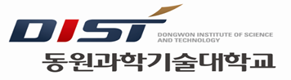 | 자기소개서(Personal Statement)自我介绍
동원과학기술대학교(DIST) 东园科学技术大学校 󰋻 학과 (Department) 学系 󰋻 한국어과정 Korea Language Program 韩国语课程
성명 (Name) 申请人姓名 |  |  | 생년월일 (Date of Birth) 出生年月日 | . .
1.가정배경 및 성장과정(Family background & Life history)家庭情况及成长过程 2.학력 (Educational background) 学历
3.유학동기(Motive of studying) 留学动机 4.학업계획(School - Work)学业计划 5.기타(Other)其他
※ 한국어나 영어로 타자를 치거나 깨끗이 쓸 것 (TYPE or PRINT clearly in Korean or English) 需用韩国语或英语工整书写

